BIT 4107 – Mobile Application Development
ENHANCED PROFESSIONAL STUDENT LOGBOOK
Student Name: Joyanne Wanjiku
Admission Number: BIT/2024/57080
School/Faculty: Computing and Informatics
Programme: BSCIT
Academic Year: 2026
Semester: Year 3 Sem 2
Lecturer: MR Nyoro
Phone Number: 0796820826

Instructions
This logbook is used to document weekly learning activities, practical exercises, skills acquired, challenges encountered, solutions applied, and reflections. Students should complete all sections every week.
Each week to follow remarks in week 1 section.

Autogenerated Table of content

Week 1: Introduction to Mobile Application Development
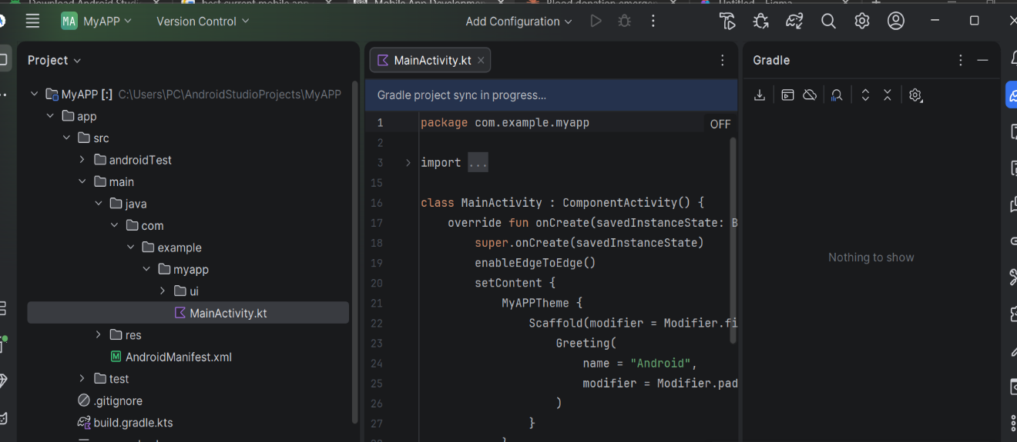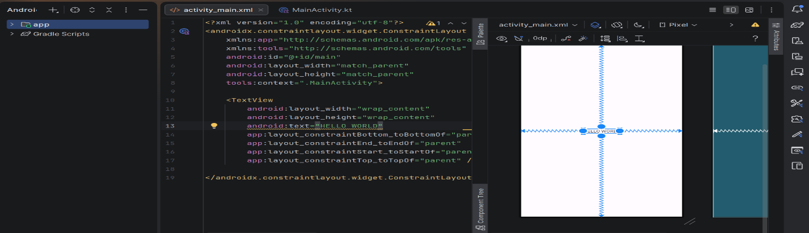

Tools/Software Used

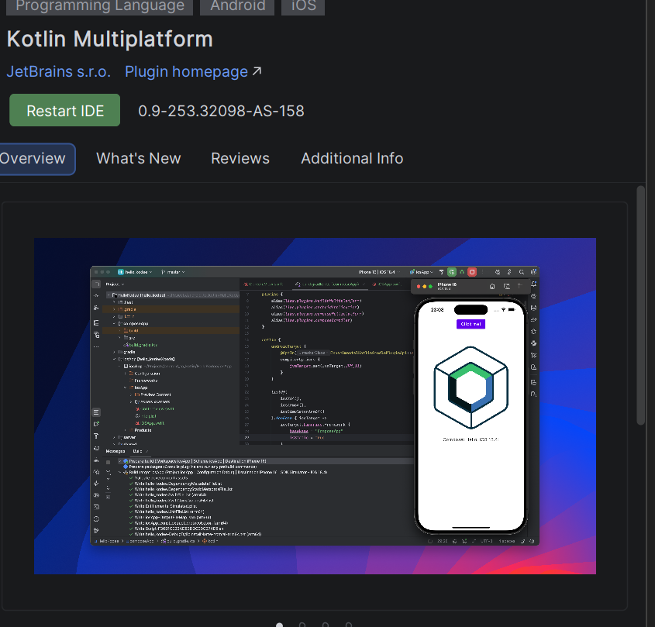
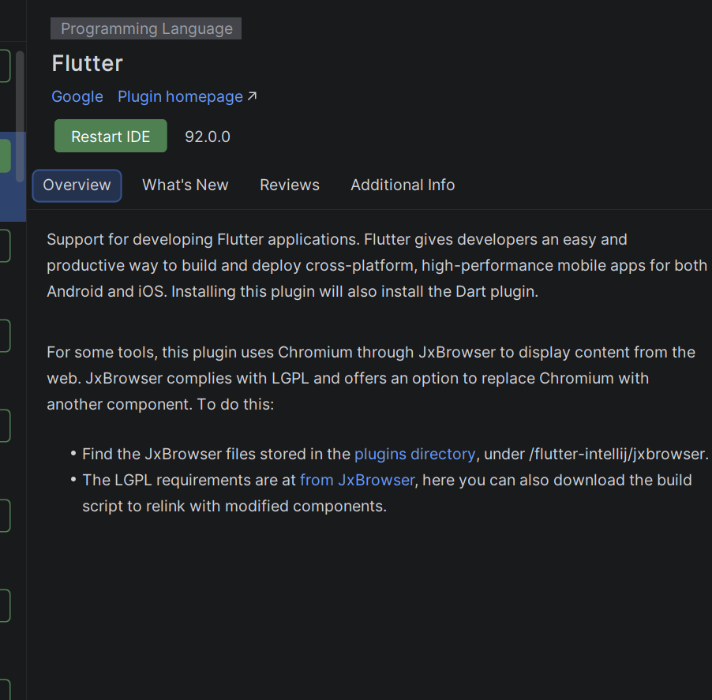

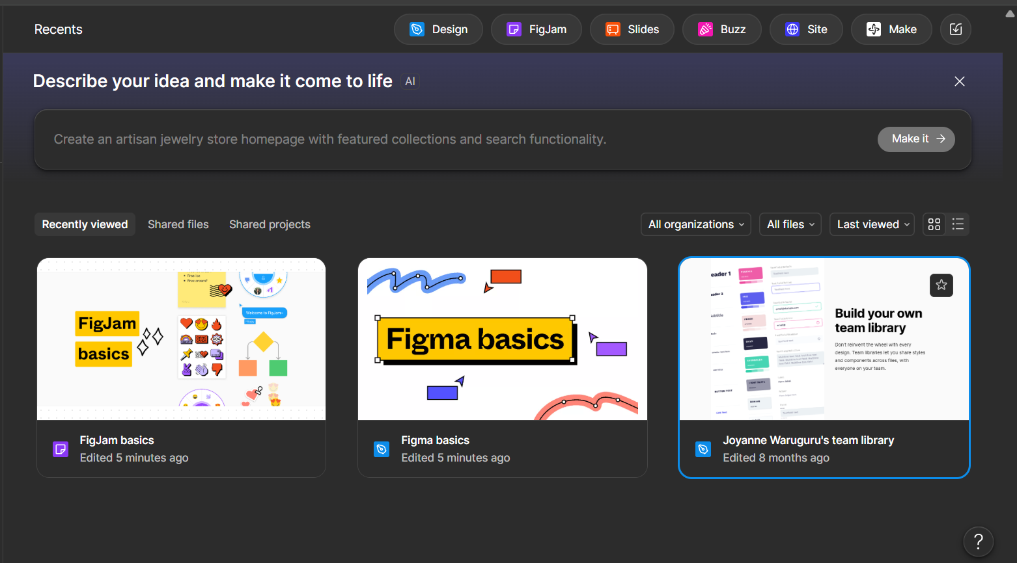

Personal Reflection
not more than 50 words
Developing the Offline AI Learning App helped me understand mobile app design and development. The project showed how technology can support students by providing learning resources without internet access, making education more accessible, flexible, and reliable in areas with limited connectivity.

Week 2: Mobile Development Environment
Install and run android studio
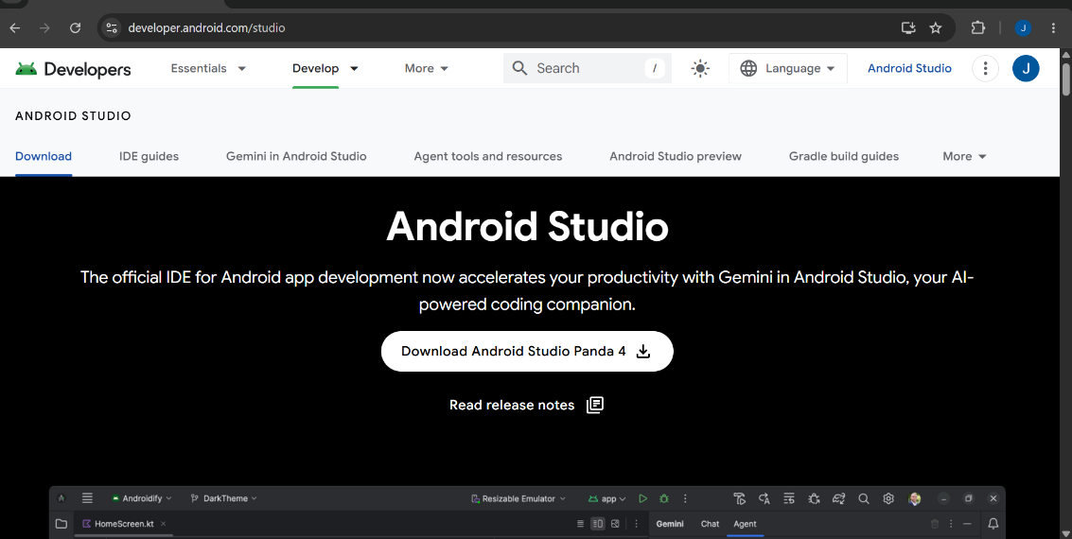
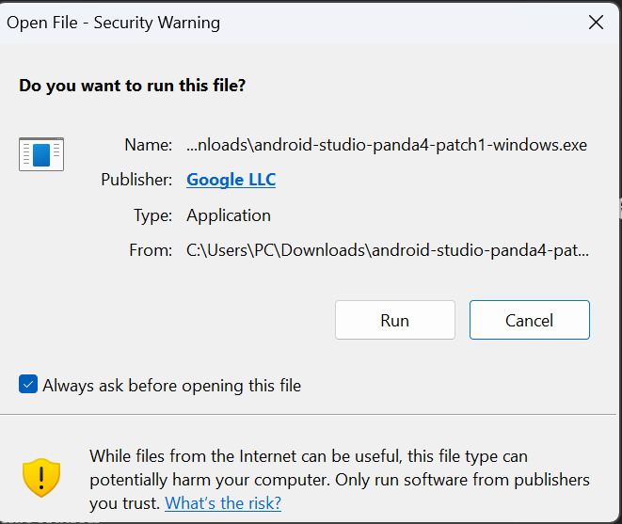


Open android studio
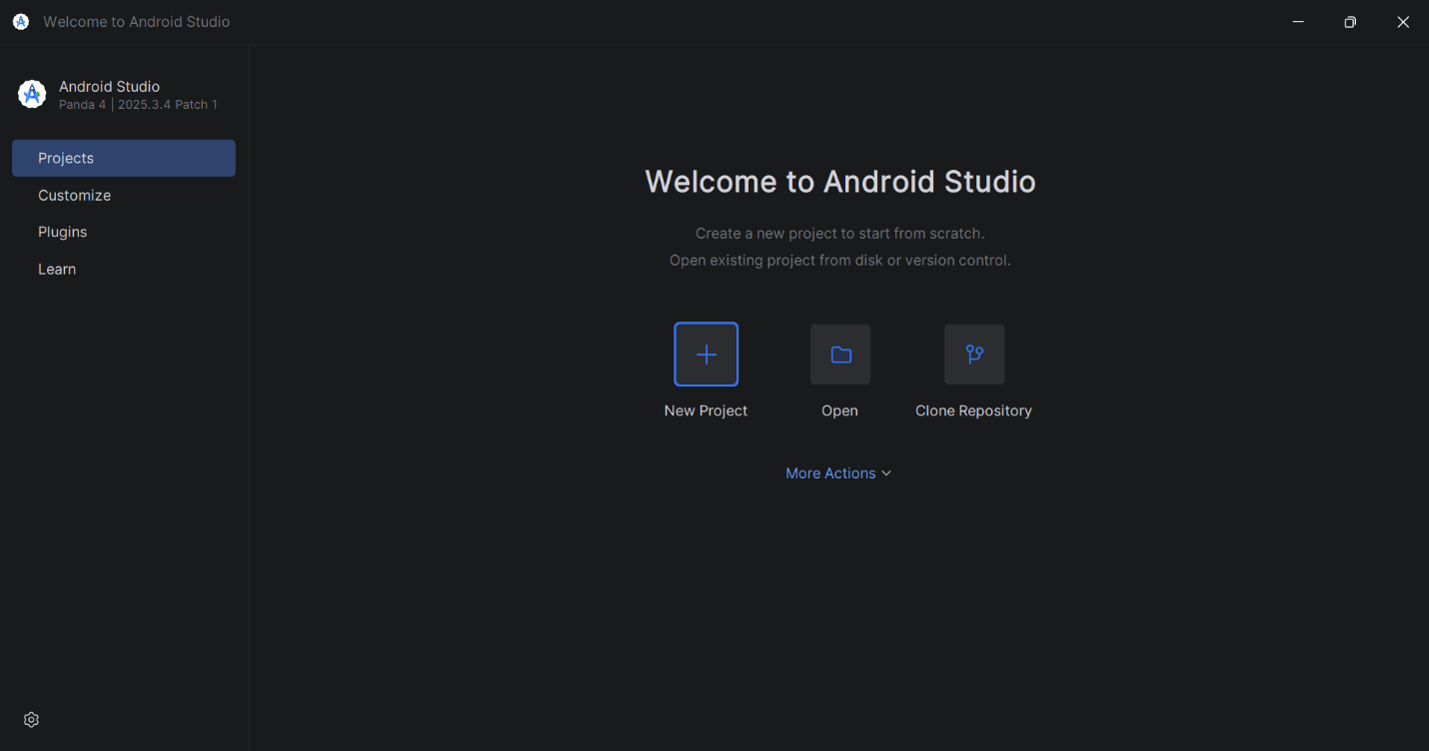
Install Kotlin plugins







Week 3: User Interface Design

UI wireframes
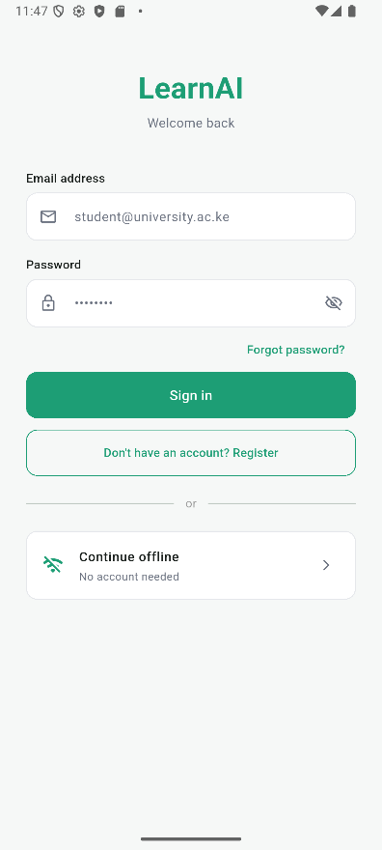
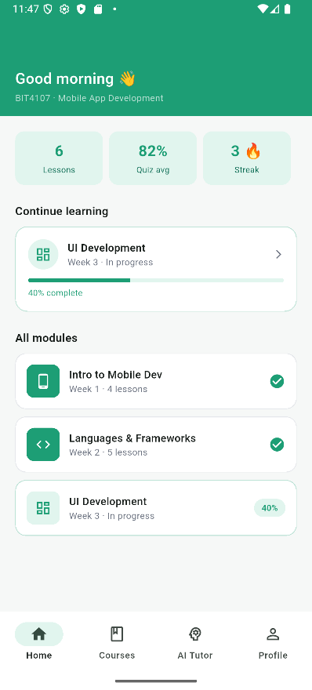
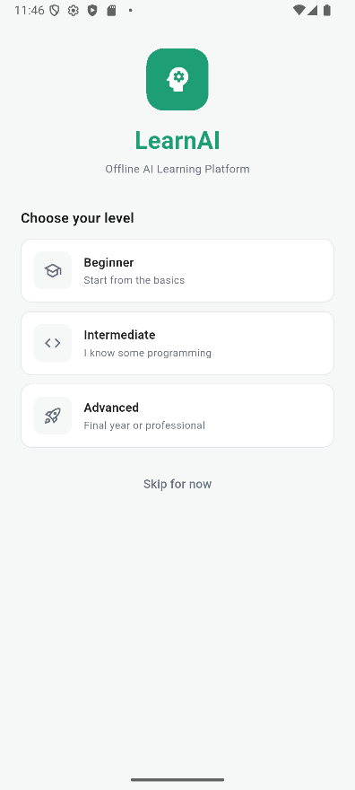

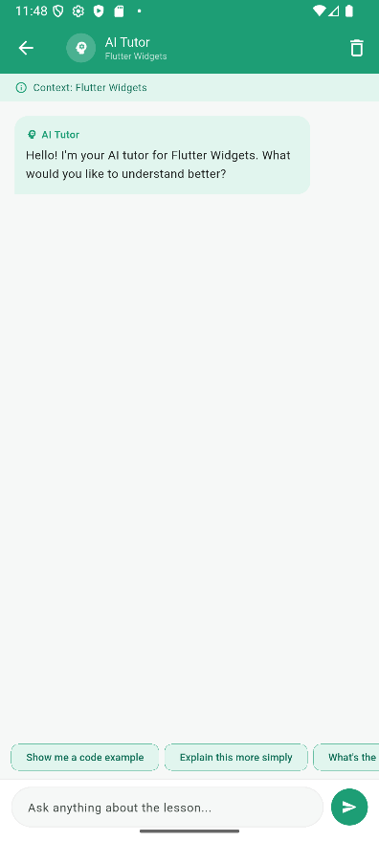
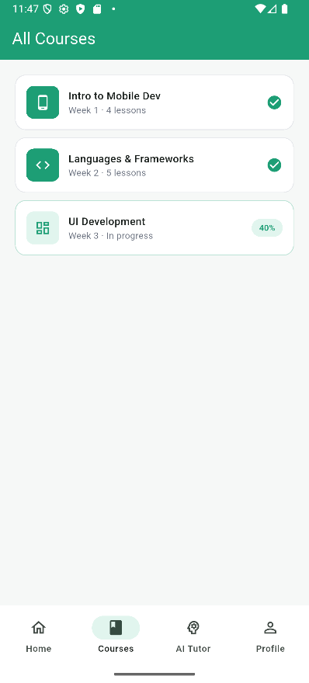
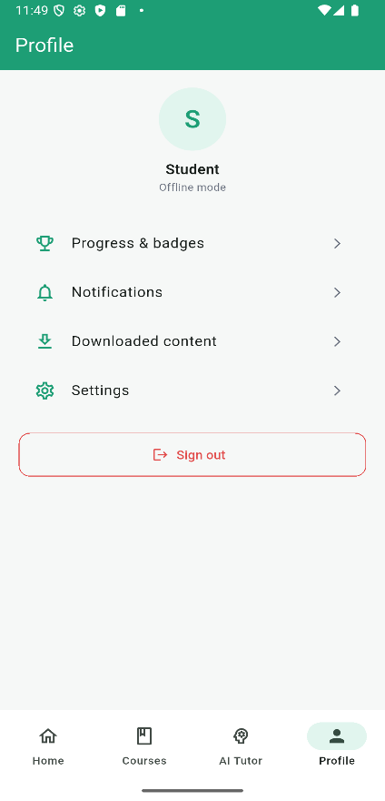
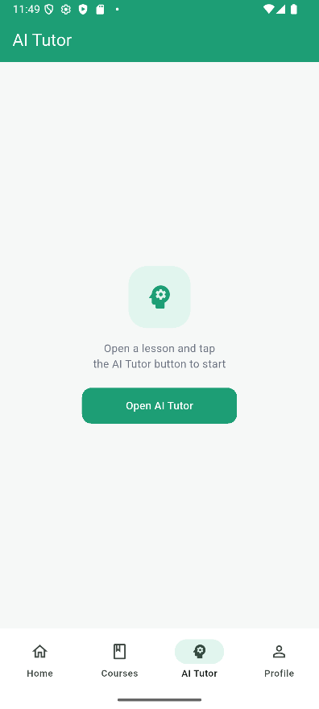

Week 4: Event Handling and User Interaction

Same as week 1

Week 5: Data Management

Same as week 1

Week 6: Networking and APIs

Same as week 1

Week 7: Application Architecture

Same as week 1

Week 8: Project Planning

Week 9: Device Features and Sensors

Same as week 1

Week 10: Notifications and Background Services

Same as week 1

Week 11: Mobile Security

Same as week 1

Week 12: Testing and Debugging

Same as week 1

Week 13: Application Deployment

Same as week 1

Week 14: Final Project Presentation

Same as week 1

Semester Project Tracking

Project Title

Project Objectives

Project Requirements

Development Milestones

Testing Results

Lessons Learned

Future Improvements

End of Semester Reflection

Summary of Skills Acquired

Most Interesting Topic

Major Challenges Faced

How Challenges Were Overcome

Professional Growth Achieved

Overall Course Experience

Final Approval
Student Name: Joyanne Wanjiku
Student Signature:
Date: _________________________________
Lecturer Name: _________________________
Lecturer Remarks: _____________________
Date: _________________________________

